**MIS 273 – Lab 5 Nano Server Install**

**Part 1 – Get a count of processes**

1. If you haven’t yet done so read chapter 11 on Nano Servers and watch the video called Microsoft Nano Server Introduction at:

<https://www.youtube.com/watch?v=XVtsw-uzovA&feature=youtu.be>

1. Login as an administrator to your Windows Server 2019 or 2016 domain controller.
2. Using PowerShell execute the following command on your Windows Server 2019 or 2016 domain controller just after you login to get a list of the processes running and a count of how many processes. You’re executing two commands separated by a semi-colon in one line here.

Get-Process; "'nNumber of processes' = $((Get-Process).count)"

Paste a screen-shot of your results of the above command in PowerShell here:

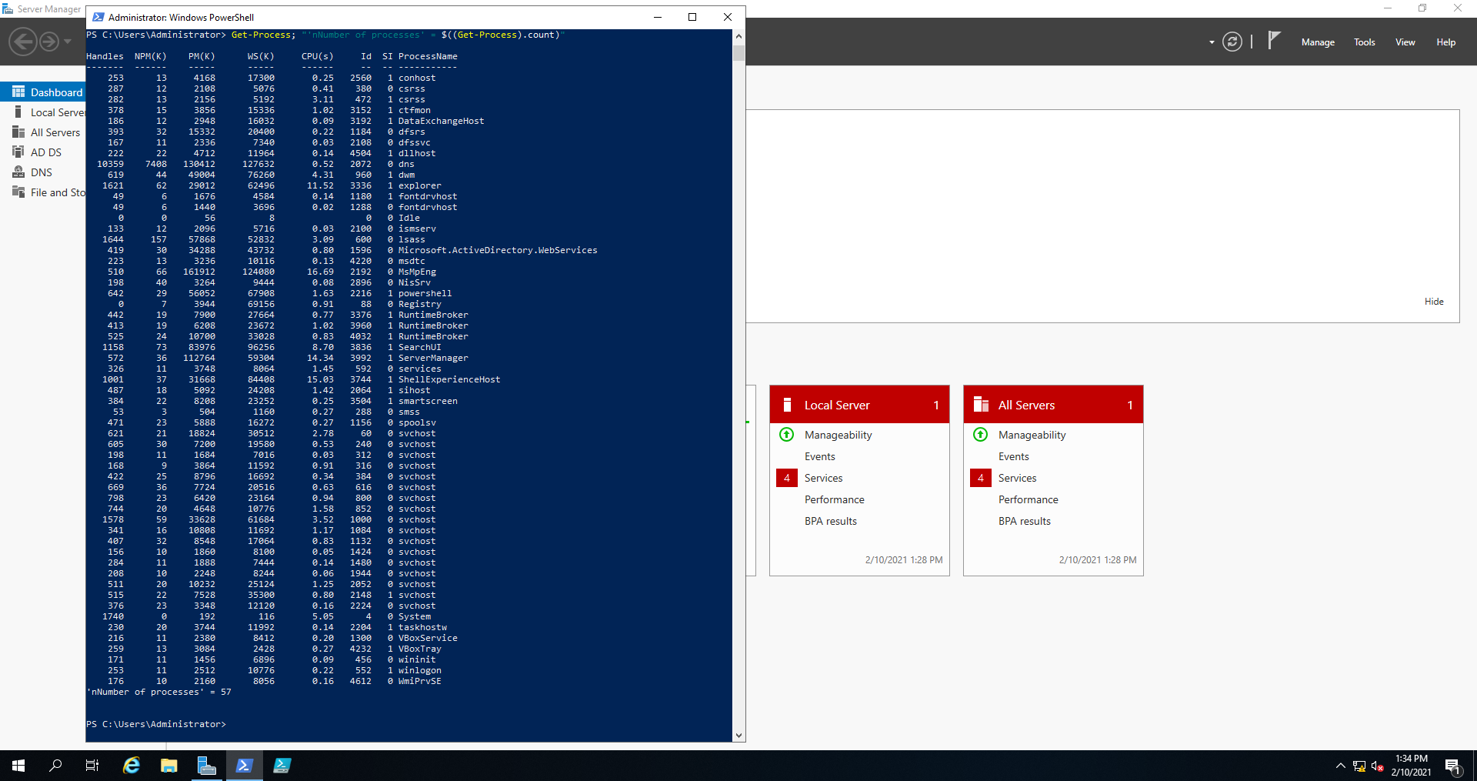

**Part 2 -** Task to accomplish: place the Windows Server 2016 ISO file into a folder on your Windows Server 2019 or 2016 virtual machine. For part 3 below, we need this ISO file stored within the Server.

1. If using VirtualBox, enable the ability to drag and drop files from your host machine to a virtual machine. To accomplish this watch the video called “VirtualBox Drag and Drop Files Feature”. You’ll find a link to the video under week 6 on Canvas.

* Use Internet Explorer to download the VirtualBox Guest Additions ISO file. The above mentioned video will discuss precise steps to accomplish this. You’ll find this ISO file at: <http://download.virtualbox.org/virtualbox/6.1.0_RC1/>
* Use the Devices menu of your virtual machine to enable Bidirectional Drag and Drop

1. Next download the Windows Server 2016 ISO file to your host machine. It will download faster to your host machine than your virtual machine. You can find a link to this file under week 6 on Canvas.
2. Create a folder for the Windows Server 2016 ISO file under the C: drive on your Windows Server 2019 or 2016 virtual machine and drag and drop the ISO file into it from your host machine.

There is no need to show you’ve done part 2 in this document (no screen-shot required). It is just preparation to do part 3 below.

**Part 3 -** **Nano Server Install**

1. If you haven’t done so yet watch the video available on Canvas called “How to install Nano Server for MIS 273”.
2. Mount the Server 2016 ISO. Note the drive letter of the mounted drive.
3. Next import the PowerShell modules needed to setup a Nano Server image where H: is the drive letter of the mounted drive. (You should use the drive letter you made note of in the previous step.)

Import-Module H:\NanoServer\NanoServerImageGenerator\NanoServerImageGenerator.psm1 -verbose

1. Create a folder in which to store the new NanoServer image. As you can see in step 5 below, my image will be stored in a folder called “VMStore” and I’m naming the vhd image “NanoServer1.vhd”
2. Create a Nano Server that includes the IIS-Package. Here’s a command that will accomplish it if the previous steps were successful.

New-NanoServerImage -MediaPath G:\ -TargetPath C:\VMStore\NanoServer1.vhd -ComputerName NanoServerFirst -DeploymentType Host -Package Microsoft-NanoServer-IIS-Package

1. Enter Standard when prompted for the edition.
2. Enter the password for your administrator account when prompted.
3. To show you’ve take a screen-shot of the folder showing the file name of the vhd file.

Paste the screen-shot here:

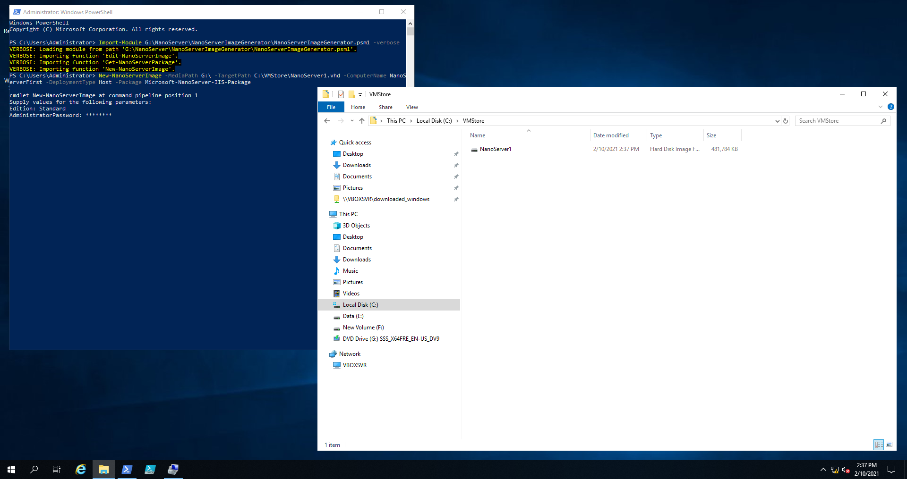

**Part 4 –** **Set up the Nano Server as a VM in VirtualBox**

1. After the Nano Server is created, copy it from the folder on your Server VM to a folder on your host machine.
2. Watch the video called “Nano Server in VirtualBox” to see how to create a new virtual machine in VirtualBox that could be used to run the Nano Server.
3. Paste a screen shot of the Nano Server Login screen to show you’ve done part 4.

Paste the screen-shot here:

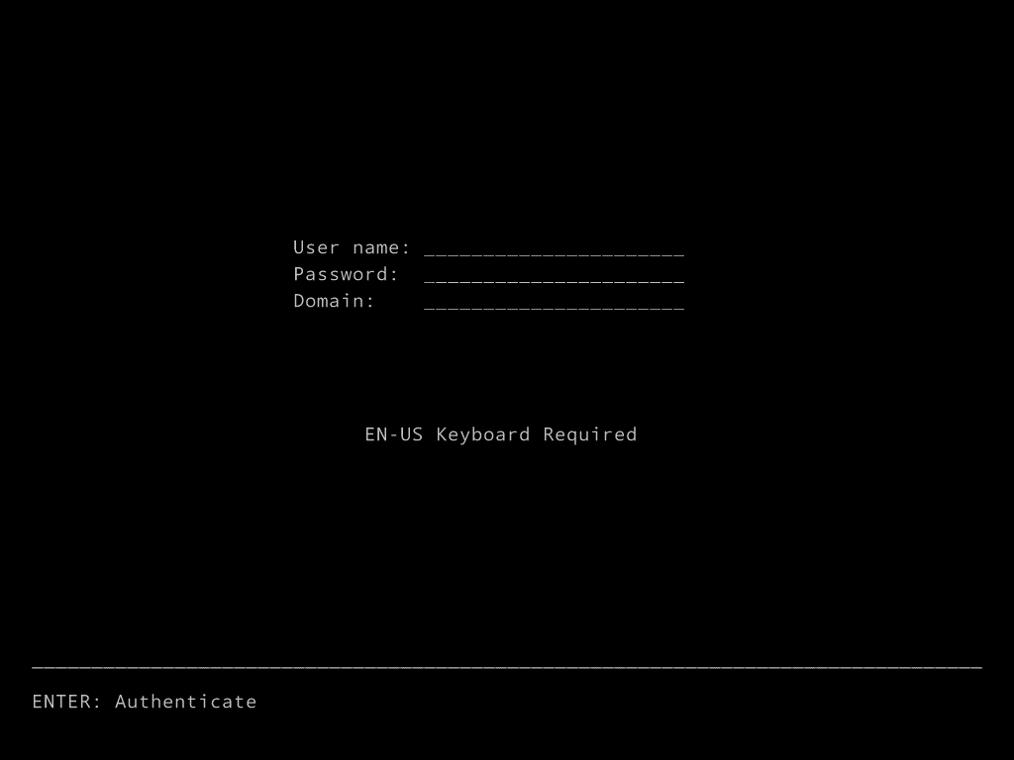

Upload this document to Canvas using the appropriate link.